

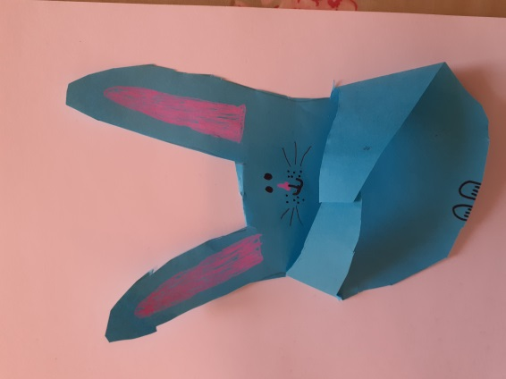
Handprint bunny
A simple Easter craft to make with your children.

You will need:
- Paper/card
- Scissors
- Pens/crayons/paints
- Hands!

What to do:
- Draw round a hand (larger hands are easiest to use.)
- Cut out, making sure you have a V shape between the fingers, rather than a curve.
- Cut a small slit beside the little finger so that the bottom of the cut lines up with the bottom of the space beside the thumb.
- Fold down the little finger towards the centre to make one of the bunny arms.
- Fold down the thumb towards the centre for the other bunny arm.
- Cut off the middle finger so you’re left with two finger “bunny ears”.
- Use a pink pen, crayon or paint to draw the pink parts of the ears. Then draw an oval for the rabbit’s nose.
- Using a black pen, draw the rest of the face – eyes, whiskers and mouth.
- Draw two little paws at the bottom of the handprint to make the bunny’s feet.

Play ideas:
- Think of your favourite emojis when you’re drawing the faces. You can make happy, surprised, excited, sad, angry or confused bunnies. You could even add heart eyes.
- Try making a selection of different coloured bunnies.
- Use glue to add different textured card/paper/match sticks, bubble wrap to the bunnies.
- Find a story that features bunnies and use them as characters of the story.
- Give your bunnies names and make up your own story.
- Put a display of bunnies on a windowsill to share the fun.

If you, or someone you know requires this document in a different format, please contact our supporter services team at supporterservices@sense.org.uk.

