­

[**www.sense.org.uk**](http://www.sense.org.uk/)

**Sense**

**College**

**East**

# *Education Provision*

# Employability Pathway

Our Employability Pathway can be accessed as a standalone option for individuals who have already identified their careers goal, and who are ready to seek work with an employer under a ‘Supported Internship’ model.







**Employability and Careers Learning:**

Sense College East offers flexible Employability and Careers Learning options designed to transition students into the workplace.

Our programmes are tailored specifically to the individual based on their education and support needs, with student interests and aspirations at the heart.

**Supported Internship:**

Learners on the Employability Pathway will spend a substantial amount of time in the workplace in a voluntary role.

Their Supported Internship is based on a ‘Place then Train’ model. This acts as an extended interview, enabling the learner to demonstrate their ability while on the job, with prospects of securing paid employment should the learner meet the required standard at the end of their Internship.





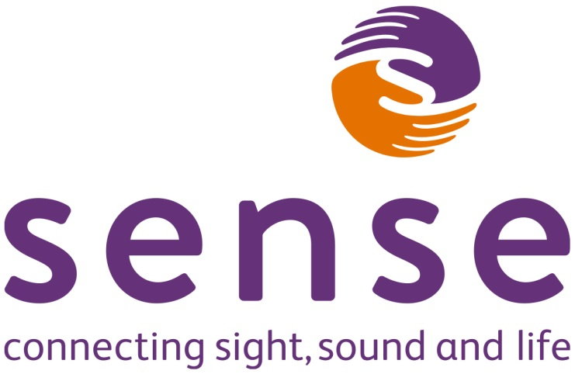­

[**www.sense.org.uk**](http://www.sense.org.uk/)

# *Education Provision*

# Benefits of accessing Employability and Careers Learning

**Sense College East enables:**

* You to gain the support needed to move into employment and develop your skills for in the workplace.
* Opportunities for additional training, to build necessary skills and qualifications.
* Support from a Job Coach using Training in Systematic Instruction (TSI) to break down tasks and skills for more manageable learning.
* Job Coach support with transitioning into the workplace.  
    
  This includes facilitating social situations, travel arrangements and support in applying for ‘Access to Work’ for reasonable adjustments, to achieve sustainable employment.
* Support to manage employer expectations, booking holidays, meeting dress codes or implementing feedback.

.

**Prior Knowledge**

Learners require prior careers information, advice and guidance to ensure the internship is the right route for them.

Those in the early stages of Careers Learning may benefit from our integrated approach offered via our Learning for Life or Foundation Learning Pathways; which help the learner to explore their potential, match and develop skills to the right job, experience taster sessions and supported work placements in the community, while linking their curriculum learning towards a career goal.





Contact us via:

Sense College East

50 Forder Way

Cygnet Park

Hampton

Peterborough PE7 8JB

01733 425053

[College.enquiries@sense.org.uk](mailto:College.enquiries@sense.org.uk)



Charity number 289868

*Version v05 / Updated: September 2023*